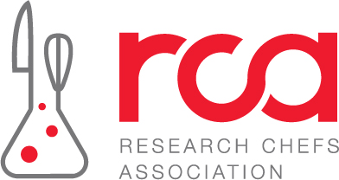

**RCA Student Advisory Program Year-End Reflection**

The RCA Professional Advisory Program is designed to match RCA student members with RCA professionals who are interested in giving back. RCA professionals will have the opportunity to help students transition into the industry by providing education, leadership development skills and professional guidance.

|  |
| --- |
| Objectives |
| 1. To maximize the benefits available to student membership and provide additional ways for RCA professional members to engage with the association. |
| 1. To provide mentorship and guidance to students on career paths, implications of decisions, and industry insights. |
| 1. To prepare and identify future leaders of the RCA. |

**Learning Outcome 1: Enhance students’ leadership skills**

What leadership skills and advice did you learn from your professional advisor?

Please rank the value of information your professional advisor provided in regards leadership skills.

1------- 2------- 3------- 4------- 5

Little Value High Value

**Learning Outcome 2: Review resumes and provide suggestions for improvement**

What recommendations did your professional advisor provide to improve your resume?

Please rank the value of information your professional advisor provided in regards to recommending suggestions for improving your resume.

1------- 2------- 3------- 4------- 5

Little Value High Value

**Learning Outcome 3: Provide career guidance and support for students who are finding their career path**

What advice or support did your professional advisor(s) offer in regards to finding your career path?

Please rank the value of information your professional advisor provided in regards to career guidance.

1------- 2------- 3------- 4------- 5

Little Value High Value

**Learning Outcome 4: Show students the best ways to network in the industry**

What did you learn from your professional advisor about networking in the industry?

Please rank the value of information your professional advisor provided in regards to networking in the industry.

1------- 2------- 3------- 4------- 5

Little Value High Value

**Learning Outcome 5: Advise students on how to stand out when searching for internships and job opportunities**

What did you learn from your professional advisor about how to stand out when searching for internships and job opportunities?

Please rank the value of information your professional advisor provided in regards to standing out when searching for internships and job opportunities.

1------- 2------- 3------- 4------- 5

Little Value High Value

**Overall**

1. What are the biggest takeaways you learned from your interactions with your professional advisor?
2. Please explain any challenges, if any, you faced with your professional advisor. *(i.e., he/she was unresponsive, poor communication, you felt the advice your professional advisor was giving was inadequate, you never felt connected with your professional advisor, etc.)*
3. How would you like to see this program improved for future RCA students?
4. Did you feel you were matched with someone who aligns with your career aspirations?
5. Did you come prepared with a list questions outside of the learning outcomes?
6. Were you able to meet your professional advisor in person?
7. How many hours did you spend on this program?